The Datsun Sumitomo Dunlop Brake Cylinder
The Datsun brake cylinder as noted in article on 311s is a Dunlop Mark II cylinder. It is single pot 2-1/8” diameter cylinder with one on each side on the caliper. There are four cylinders total with an inner and outer that are different from each other. The outside has two tube connections. The inside has a tube connection and a bleeder screw.
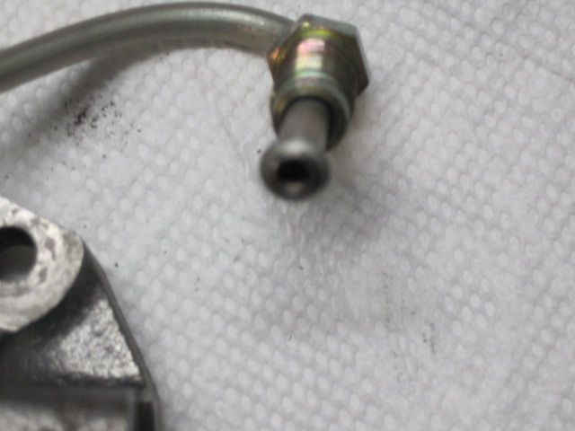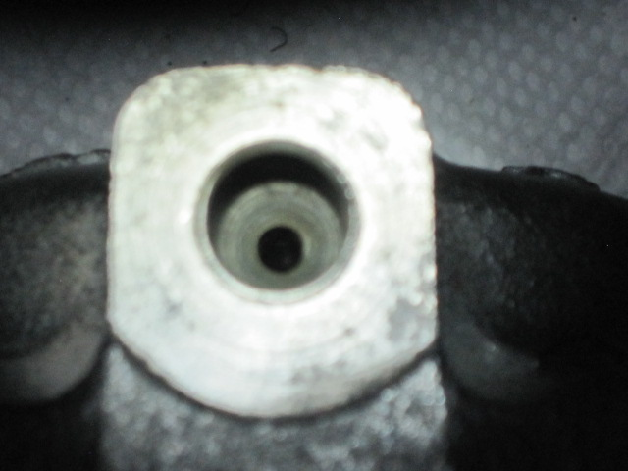When you look at the connection holes on the cylinder you see that the outside one has two concave seating surfaces.

The inside cylinder has one concave seating surface and one raised surface for the check ball and bleeder screw.
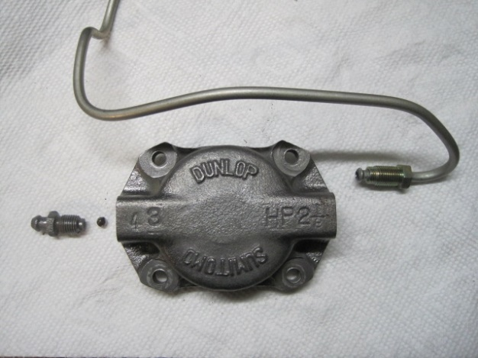
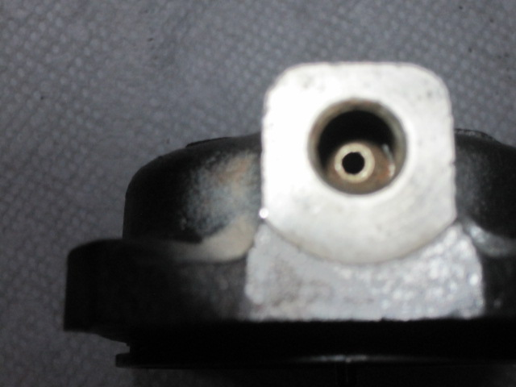

Here is the cylinder disassembled, the piston, cylinder body, piston seal and dust cover.
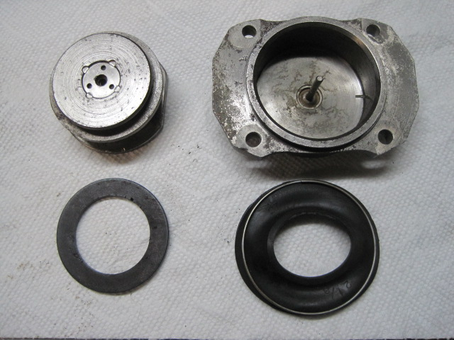
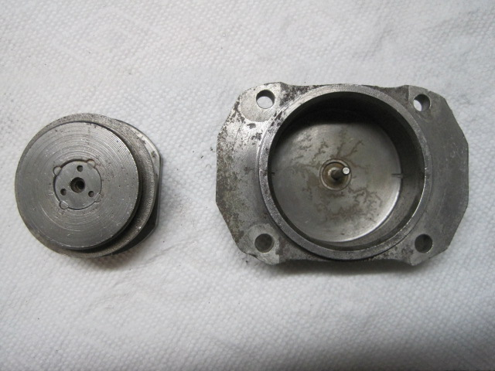

The condition of the cylinder bore determines whether you can rebuild, sleeve with brass or stainless or buy new calipers. If the wall is pitted from rust you’re not likely to get a seal that will hold and have a leaky cylinder.
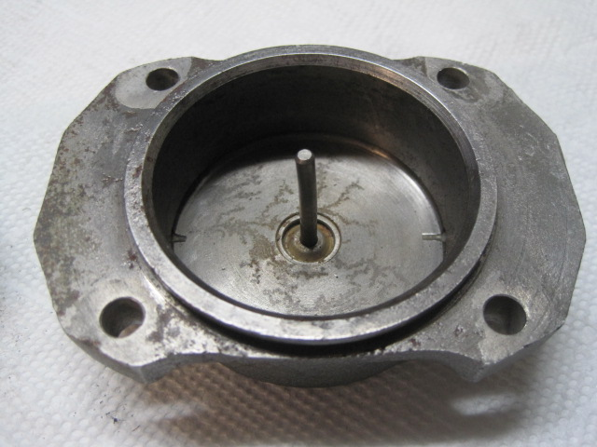

This is a cylinder that was sleeved with stainless steel. This is the condition of it after more than 15 years of use without ever having a complete flush of the brake system. It had a minor amount of debris and rust in the corner. Sealing surface was cleaned up using a Dremel tool with the steel wool type wheel. Not one pit in it.
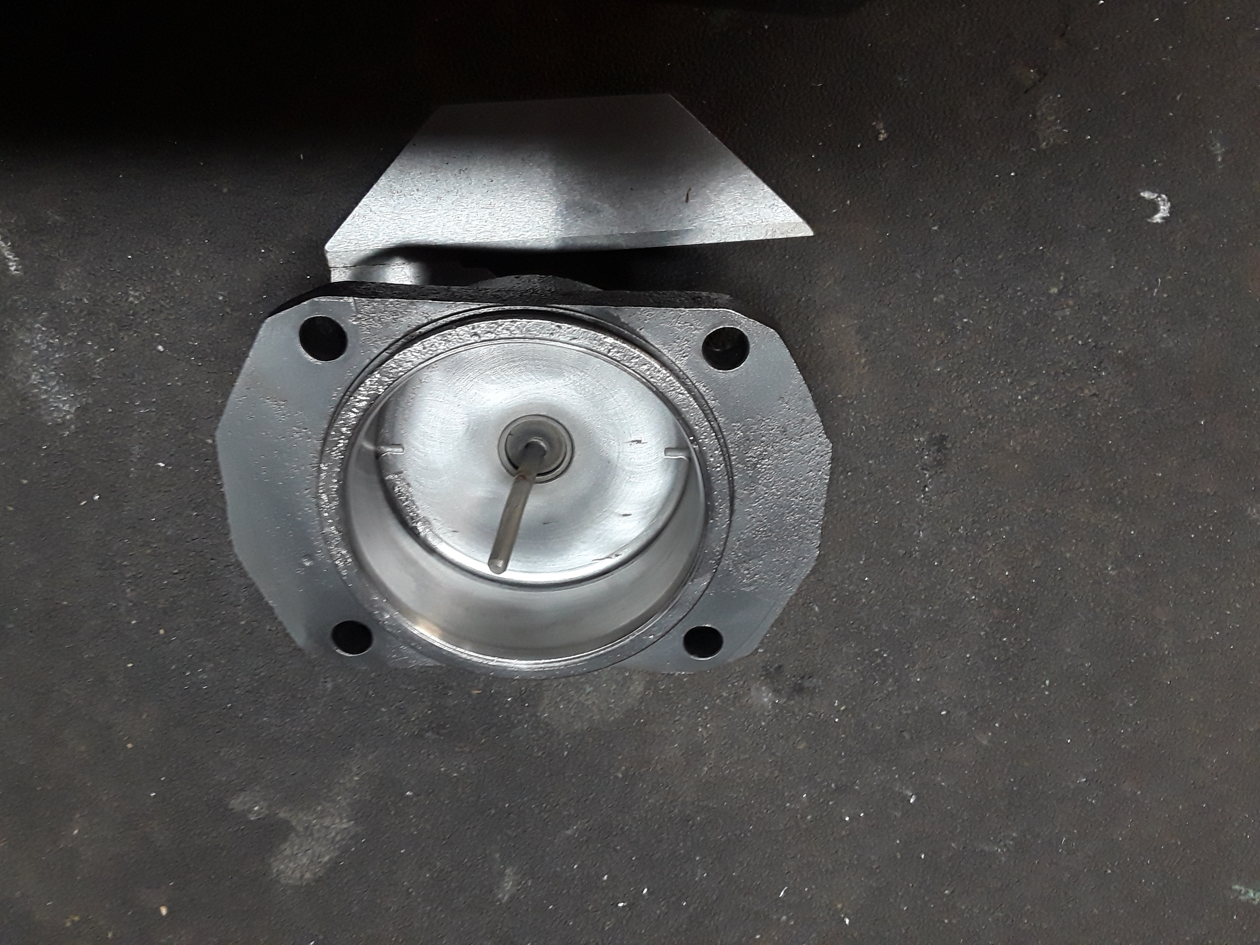

Assembled cylinder.

Photo

For an easier time bleeding the brakes you can replace the stock bleeder and ball with a speed bleedr. The speed bleeder has a spring loaded check ball inside and prevents air from entering back in to the cylinder.
Photo

As I recently learned due to 311s the brake pads are directional. There are two raised squares and an arrow indicating which side the pad should be inserted.
photo

Exploded right caliper assembly.
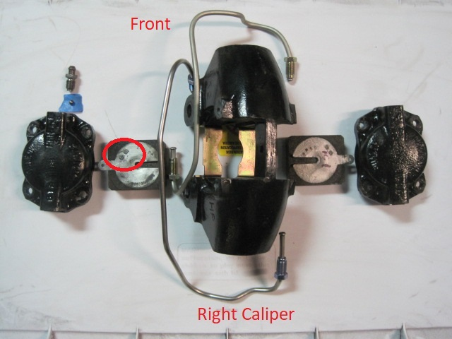

Assembled right caliper assembly.

